Vision Transformers (ViTs)
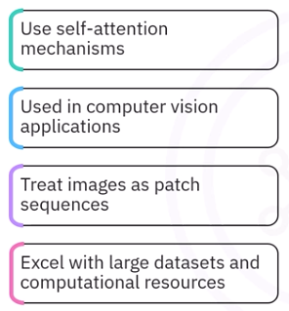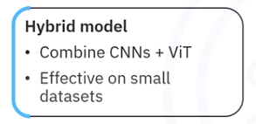

How ViTs Work
- Patchififcaiotn and mebedding positional encoding passign through transformer encoder blocks classification
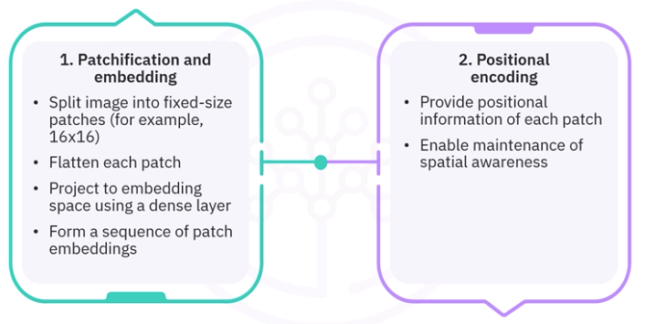
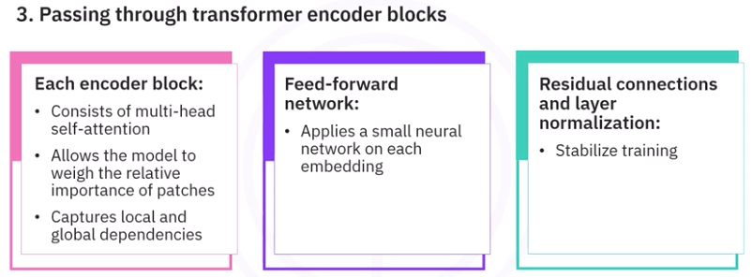

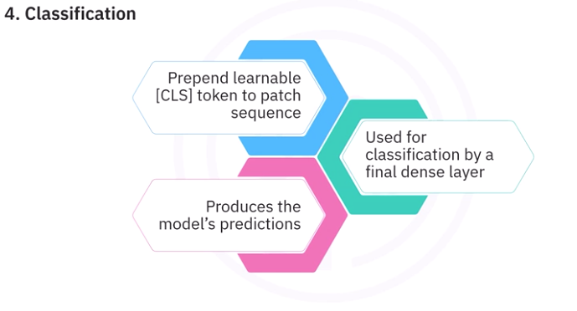

Vision Transformers and Transfer Learning
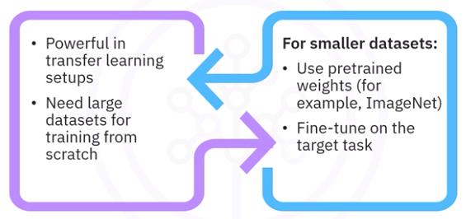
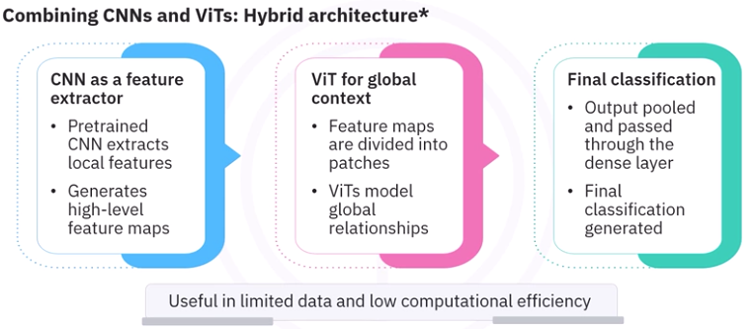

Mechanistic Details
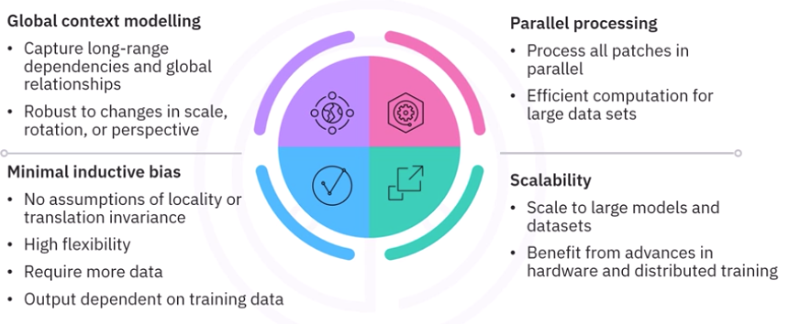

ViTs in Keras and Pytorch
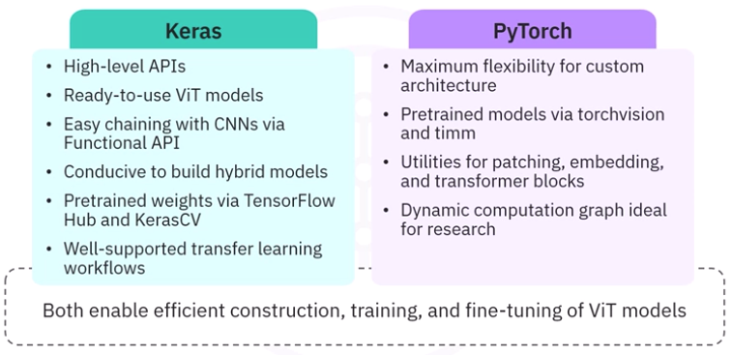

Advantages and Limitations of ViTs
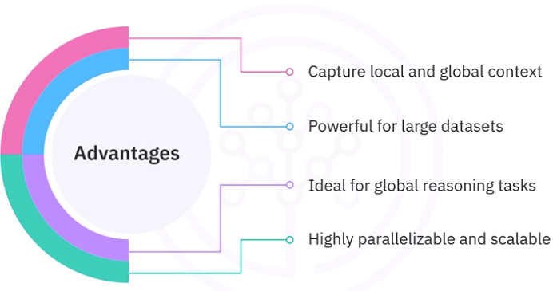
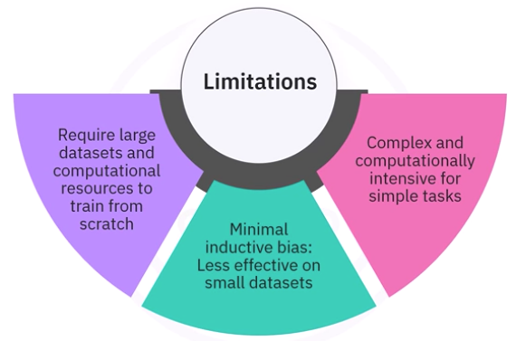

At InnovateAI, a team of AI engineers led by Sarah is tasked with developing an image classification model using Keras. They decide to leverage vision transformers and transfer learning. What should be their initial step in implementing this model?
Collect a large dataset to train the vision transformer from scratch
Design a custom vision transformer architecture from scratch
Load a pre-trained vision transformer model and prepare the dataset for transfer learning
Implement a convolutional neural network as a baseline before using vision transformers
Starting with a pre-trained model allows the team to leverage existing knowledge and adapt it to their specific dataset, which is a key aspect of transfer learning.

Imagine that at AI Solutions Corp., the team led by Jamie is tasked with summarizing the use of vision transformers in Keras. What aspect should they emphasize to demonstrate the application of transfer learning in computer vision tasks?
The necessity of large datasets to train vision transformers effectively
The ability to adapt pre-trained models for specific tasks with minimal data
The requirement for extensive hyperparameter tuning in every application
The exclusive use of convolutional layers in vision transformers
This is a core advantage of transfer learning, allowing models to be tailored to new tasks efficiently.

At TechVision Inc., Alex is implementing a vision transformer model using PyTorch for a domain-specific image dataset. Which key step should Alex focus on to effectively apply transfer learning?
Use the model without any modifications on the new dataset
Train the model from scratch with the new dataset
Implement additional layers to the existing model
Fine-tune the pre-trained model on the new dataset
Fine-tuning involves adjusting the pre-trained model to better fit the new dataset, which is a crucial step in transfer learning.

What is the function of the self.features module inside the ConvNet class?
It loads the dataset into the model.
It computes the loss for the model during training.
It applies the pre-trained model architecture for CNN-based feature extraction.
It implements the transformer encoder for the hybrid architecture.
In the ConvNet definition, the self.features module defines the architecture of the pre-trained CNN model to process and extract hierarchical features from images using pre-trained model weights.

What is the primary operation performed by the PatchEmbed class's proj layer in the Vision Transformer implementation?
Projects the input feature map to a lower-dimensional embedding using a 1×1 convolution
Applies a pooling operation to flatten patches
Divides the image into overlapping patches using a 3×3 convolution
Flattens the original image directly into a sequence
The PatchEmbed class employs a 1×1 convolution via self.proj to convert feature maps into embeddings, serving as input tokens for the transformer.
When creating the positional encoding for image patches, which of the following operations is typically performed?
Adding a learned or fixed vector to each patch embedding
Subtracting the patch mean from each patch
Concatenating zeros to patch vectors
Reshuffling the patches randomly each epoch
Positional encoding involves adding a unique vector (learned or fixed) to each patch's embedding to retain positional information.

During Vision Transformer training, what is the typical purpose of including a "Classification Head" at the end of the model?
To increase model regularization
To project the final encoder output to the number of target classes
To encode positional information
To resize the image to its original shape
The classification head is a Dense layer that outputs logits or probabilities for each target class, enabling end-to-end training for classification tasks

